|  |  |  |  |
| --- | --- | --- | --- |
| 1 | | 21,744.0 | |
| NUMERO DE FRONTERAS | | ENERGIA AGREGADA | |
|  | | | |
| SI | | 31-12-2020 | |
| CONTRATO | | VENCIMIENTO CONTRATO | |
|  | | | |
| 29,990,904 | 59 | | 1,266,413 |
| INGRESO 2020 | DÍAS CERTIFICADOS 2020 | | ENERGIA RESPALDADA 2020 |
|  | | | |
| 14,713,576 | 30 | | 652,320 |
| INGRESO 2021 | DÍAS CERTIFICADOS 2021 | | ENERGIA RESPALDADA 2021 |

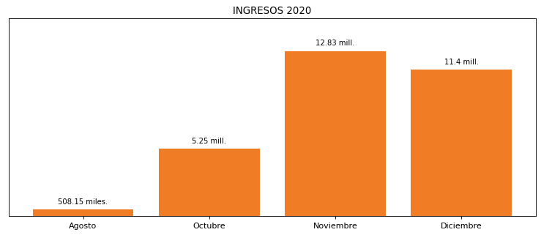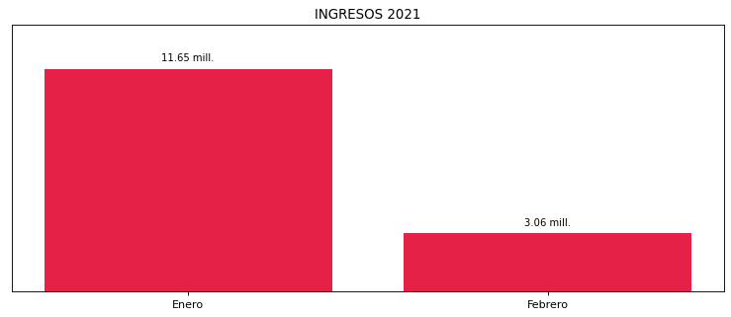

|  |
| --- |
| **COCA COLA BARRANQUILLA**  USUARIO |

|  |
| --- |
| **Mateo Porras**  Ejecutivo de cuenta |

|  |
| --- |
| **0**  PUNTO FOCAL |

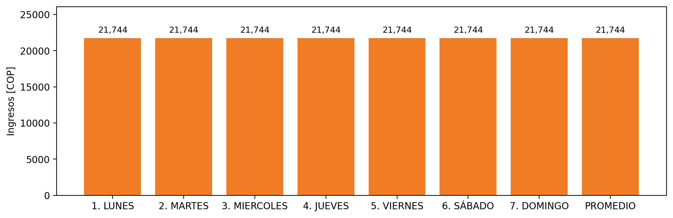

|  |  |  |  |  |  |  |  |  |  |  |
| --- | --- | --- | --- | --- | --- | --- | --- | --- | --- | --- |
| **FRONTERA** | **COD SIC** | **PREDIO** | **FRT DDV** | **TIPO DDV** | **PROMEDIO** | **PRÓXIMA ACTUALIZACIÓN** | **MARGEN DE ERROR** | **ÚLTIMA PRUEBA DDV** | **DÍAS PARTICIPACIÓN** | **FECHA REFERENCIA PRÓXIMA PRUEBA DDV** |
| INDUSTRIA NACIONAL DE GASESOSAS S.A. | Frt00477 | Prd02060 | Frt38172 | GPE | 21,744 | 2023-04-15 | NO APLICA | 2020-10-11 | 88.0 | 2021-12-05 |